PROJECT 3 (DICT300) PROJECT PLANNING SUBMISSION

In your assigned groups, finalize and submit the project planning document according to the provided submission guidelines or instructions outlined below.

**DOCUMENT INSTRUCTIONS**

**The template must have:**

1. Cover page:

The cover page should have the following (the topic of the system, the group name, group members and student numbers, version number of the document)

e.g.



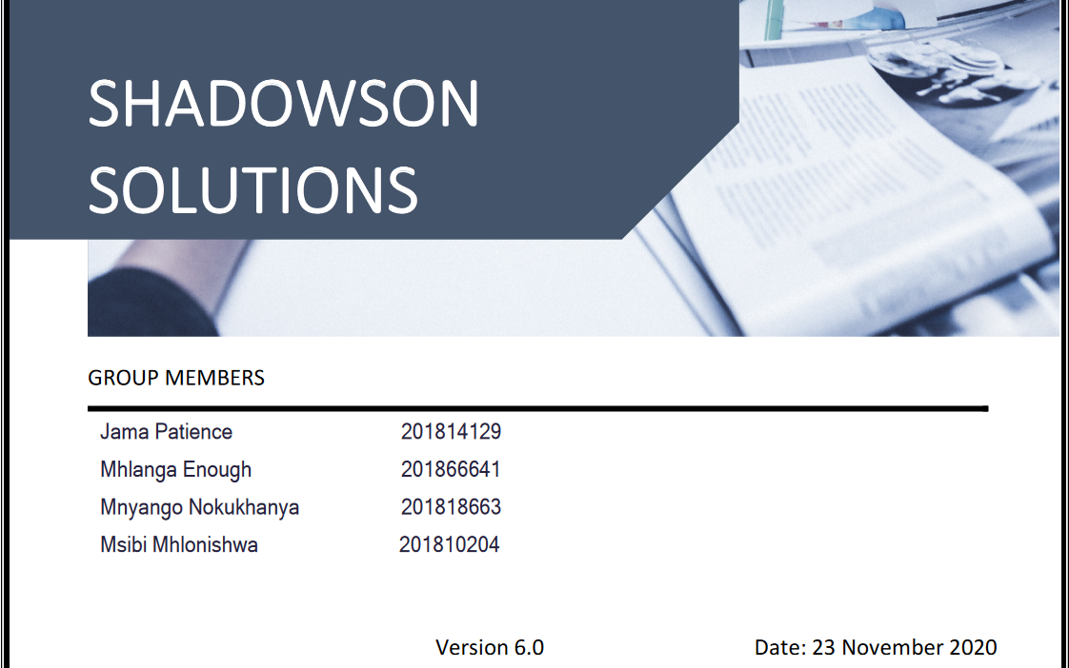

1. Timetable

The time table should show the project planning including dates. E.g.

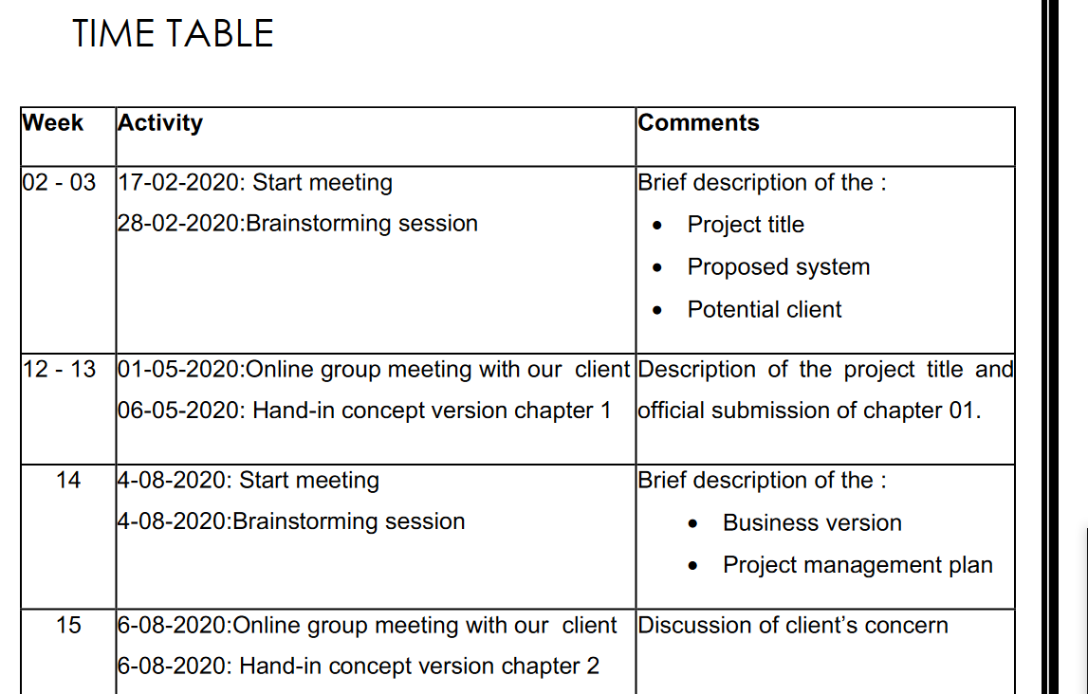

1. Revision history

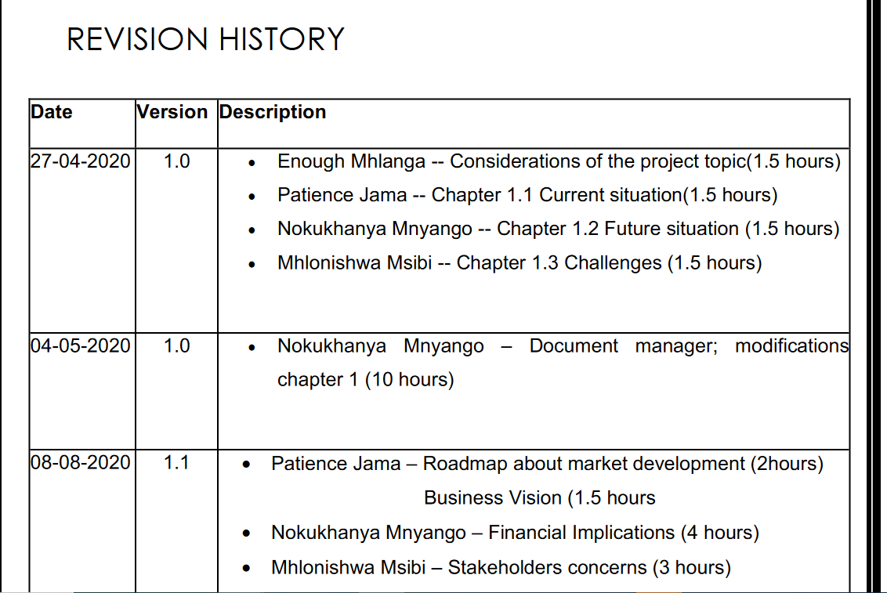

# Document format

* All document submissions should be written in Arial font and font size 11.
* The document should use proper heading
* All documents should use line spacing 1.5 with justified alignment. E.g.

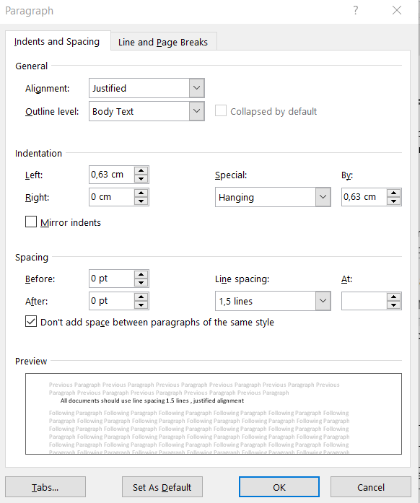

* Use page numbering and automated table of contents.
* Plagiarism is not allowed: use tools like Grammarly for grammar formatting.

**Chapter 1**

**System context**

|  |  |
| --- | --- |
| 1.1 | Introduction |
| 1.2 | Current system |
| 1.3 | Proposed System |
| 1.4 | Challenges |

**Chapter 2**

**Business vision**

|  |  |
| --- | --- |
| 2.1 | Business vision |
|  | 2.1.1 Description of envisaged business opportunities and unique selling points |
|  | 2.1.2 Advantages and disadvantages |
| 2.2 | The business rationale |
| 2.3 | Product description and its evolution over time |
| 2.4 | Target audience |
| 2.5 | Business or domain model |
| 2.6 | Roadmap about market development |
| 2.7 | Financial implications  2.7.1 Development costs  2.7.2 Unit costs and investment  2.7.3 Operational costs  2.7.4 Profit system  2.7.5 Break-even point  2.7.6 The advantage for the customer |
| 2.8 | Stakeholder concerns |
| 2.9 | Project plan |